
PRR&VS GOVERNMENT COLLEGE, VIDAVALUR, NELLORE DIST.

(Accredited by NAAC with ‘B’ grade)

Best Practices

One Day – One Plant
Followed from
2022-23……

ORGANISED BY

DEPARTMENT OF BOTANY

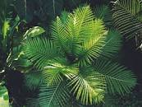

PRR&VS GOVERNMEN COLLEGE, VIDAVALUR, NELLORE DIST.

(Accredited by NAAC with ‘B’ grade)

Best Practices

One Day – One Plant
Followed from
2022-23……
Studying Botany is recognized as one of the most engaging, environmentally-friendly thinking that people can participate in to help the planet when acquire knowledge of plants. Trees provide numerous long- term and short-term benefits. They not only look nice, but they also remove and store carbon from the atmosphere, slow heavy rain and thus reduce the risk of flooding, improve air quality, and reduce the urban heat island effect by reflecting sunlight and providing shade.

AIMS and OBJECTIVES:

- To provide knowledge of plants present surrounding of college and neighboring villages.
- To know the names of various plants with their scientific name and vernacular names.
- To utilize the knowledge of old and experienced people who are rich in traditional knowledge of plants and their medicinal value.
- To know the biodiversity of native flora and its significance.
- To conserve the biodiversity of native flora.
- To prepare herbarium of native plants.

PRACTICE:

  - Collecting a plant in a day.
  - Displaying the plant on the bulletin board.
  - Displaying the plant scientific name and vernacular name, name of the family of plant on the bulletin board.
  - Adding notes on medicinal values of the plant.
  - Recording the entire in note books and to prepare report on the entire activity.

GOAL: to provide basic knowledge of native plants .

CONTEXT:
    - Now a day it is become mandatory cut the trees of forests for widening of roads, construction of buildings and to establish industries. So many plants are being removed from dwelling areas.
    - So it is important to know the plants present in our native place and to reintroduce the plants from the neighboring places.
PRACTICE:
The teacher guides students to pick up native plants from their villages. Students are asked to write the medicinal and religious importance of the plants collected and to plant the plants in the context of World Forest Day , World Earth’s Day etc;
EVIDENCES OF SUCCESS:
The success of this practice is evident in the students’ recording the data, bringing the plants from their villages, plantation and distribution of plants.

PROBLEMS ENCOUNTERED:
It is difficult to identify the importance of plants without the help of old people and experts who known medicinal and religious importance of plants in villages.

RESOURCES REQUIRED:
- Department of Botany in collaboration with NSS Unit regularly takes up plantation in the college campus.
- Student interest and support in bringing the plants.

EVIDANCES-

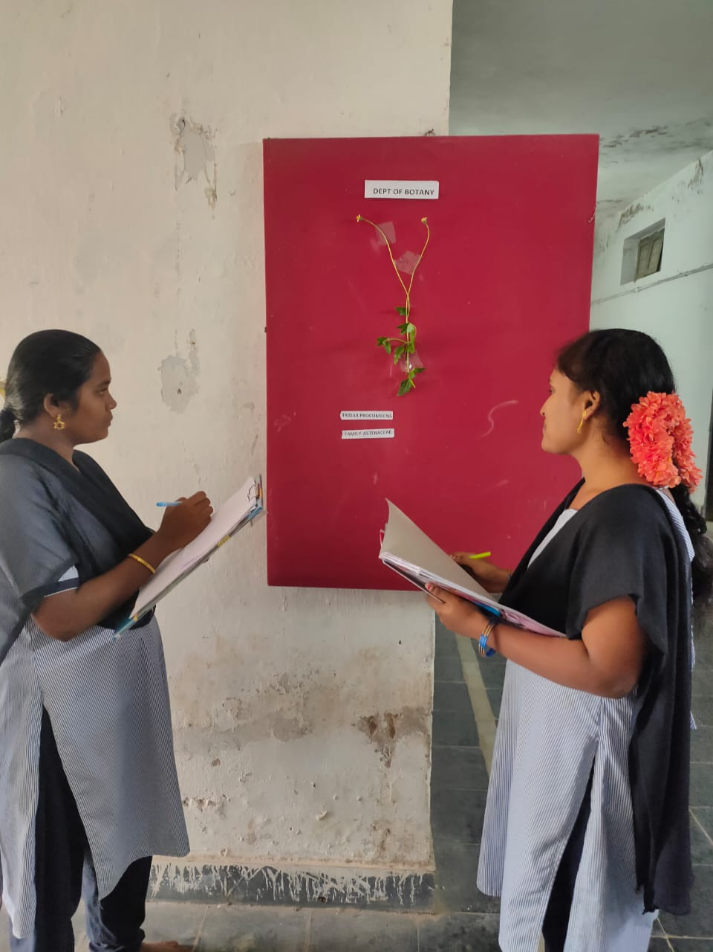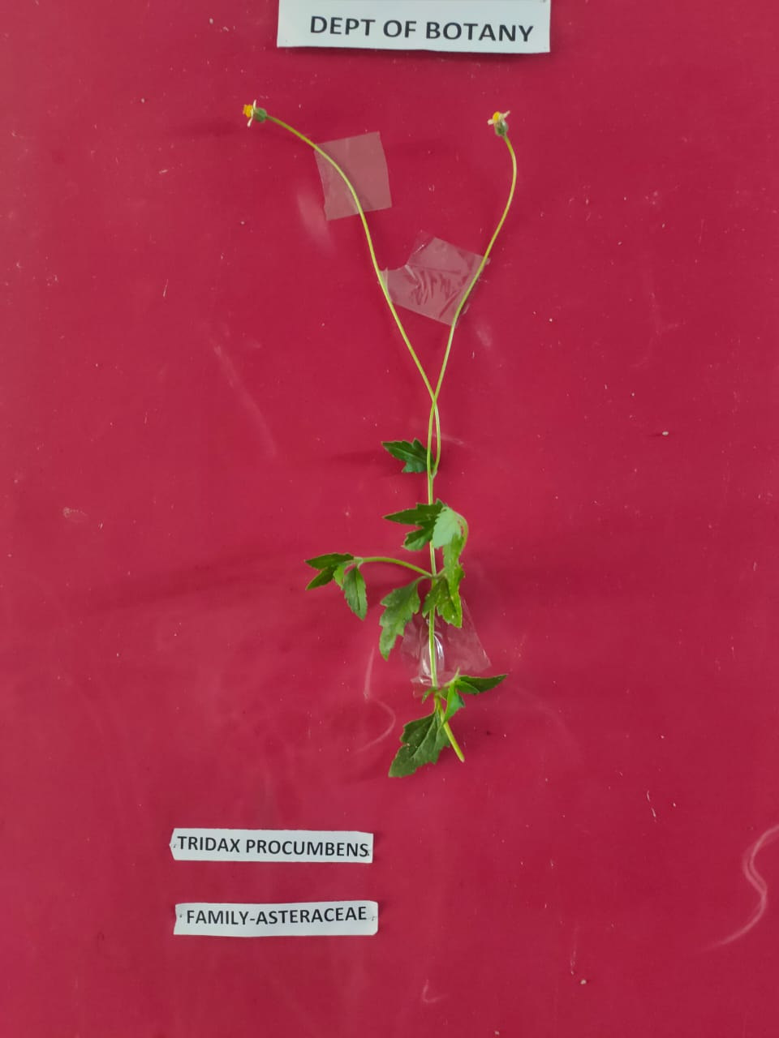
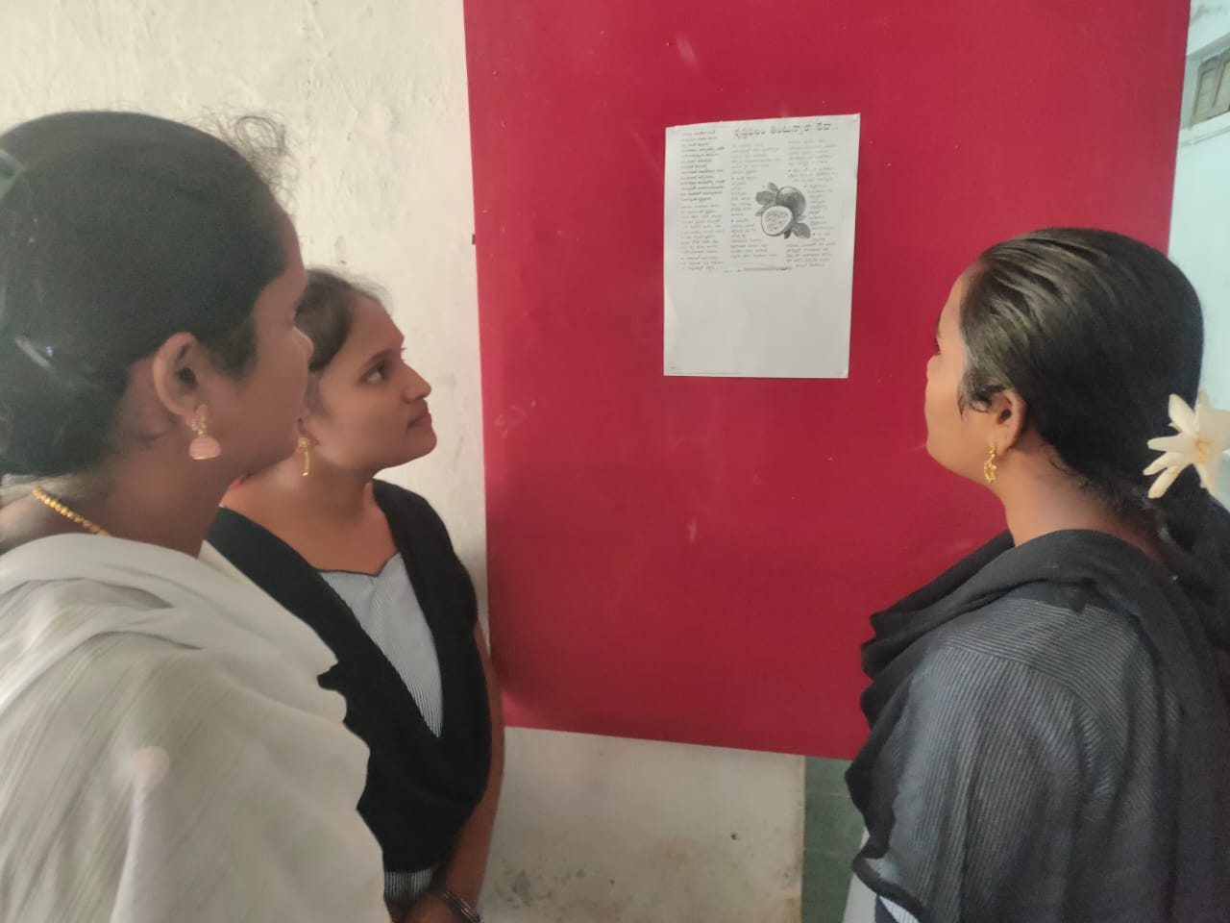

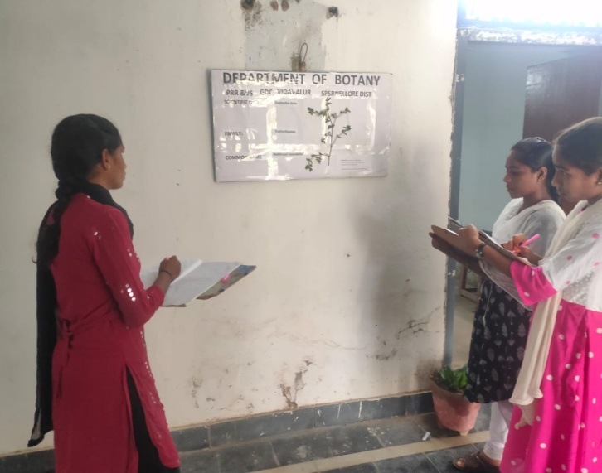

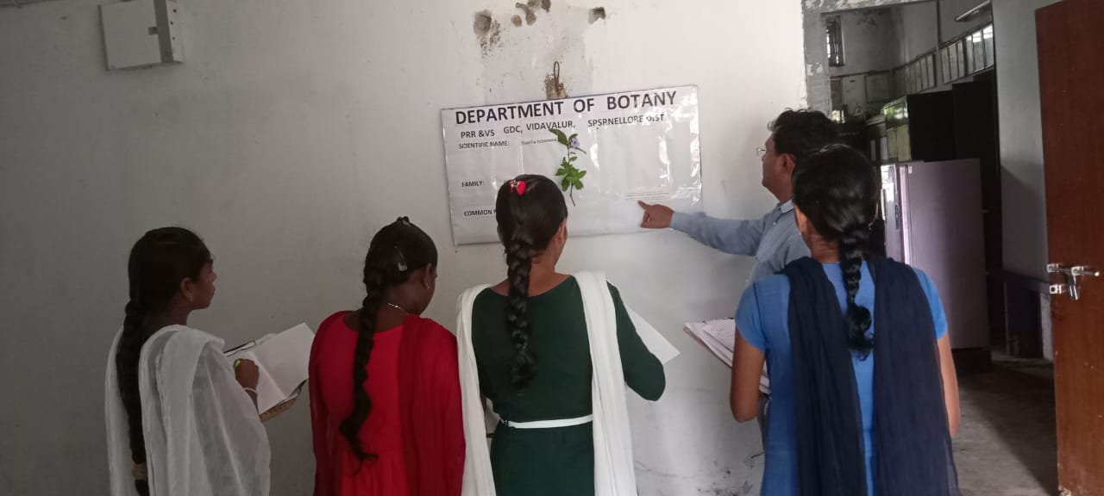

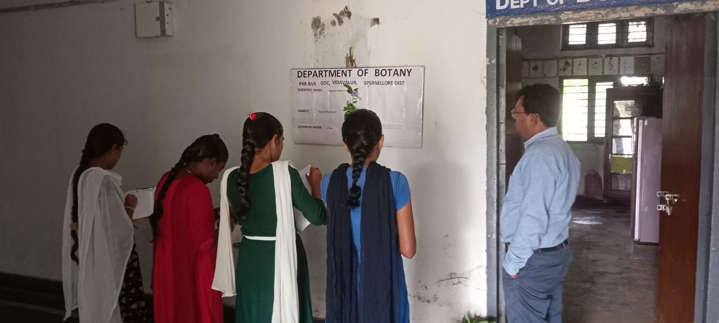
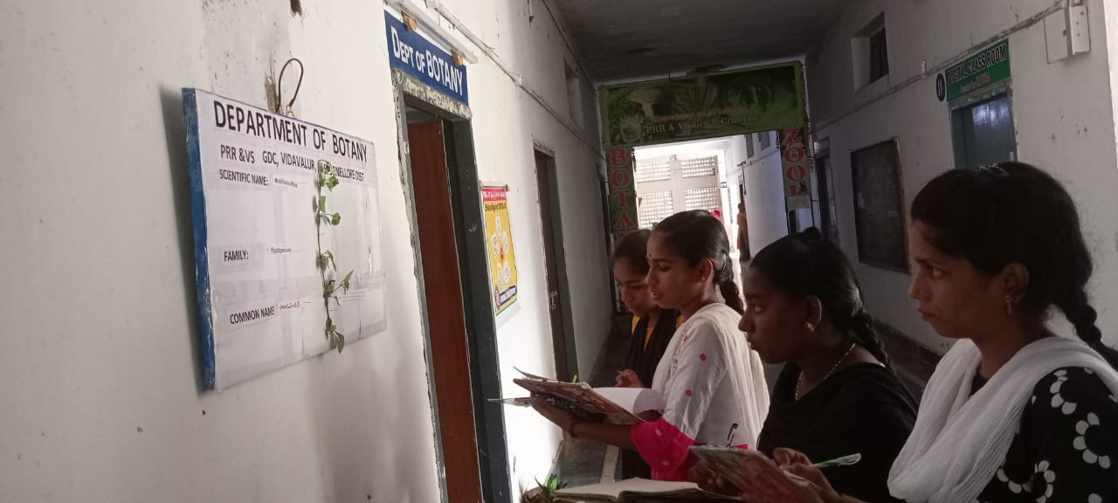

LIST OF PLANTS DISPLYAED ON DISPLAY BOARD

S.NO | NAME OF THE PLANT | FAMILY | VERNACULAR NAME
1 | Parthenium histerophorus | Asteraceae | Vayyaribhama
2 | Moringa oleifera | Mringaceae | munaga
3 | Abutilon indicum | Malvaceae | Thuttarabenda
4 | Commelina bengalensis | Commelinaceae | Amruthakada
5 | Coccinia cardifolia | Cucurbitaceae | Donda
6 | Tribulus terrestris | Euphorbiaceae | palleru
7 | Euphorbia hirta | Euphorbiaceae | Reddivaari naanabaalu
8 | Acalypha indica | Euphorbiaceae | Muripinda
9 | Tridax procumbens | Asteraceae | Gaddichamanthi
10 | Passiflora indica | Cucurbitaceae | jumkipuvvu
11 | Phyllanthus neruri | Euphorbiaceae | Nela usiri
12 | Croton banplandianum | Euphorbiaceae | Galivana mokka
13 | Calotropis gigantia | Asclepiadaceae | Jilledu
14 | Boerhaavia diffusa | Nyctagenaceae | Atika mamidi
15 | Ruellia tuberosa | Acanthaceae | Chebeera
16 | Aeruva lanata | Euphorbiaceae | Kondapindimokka
17 | Lantana camera | Verbenaceae | Talambrala chettu
18 | Solanum melangena | Solanaceae | Vankaya
19 | Azadirakhta indica | Meliaceae | Neem
20 | Hibiscus hirtus | Malvaceae | Mallow plant
21 | Cleome chelidoni | Cappriadaceae | Celandine climber
22 | Celosia argentia | Amaranthaceae | Gurugu
23 | Clitoria turnata | Fabaceae | Butterfly pea
24 | Tephrosia purpurea | Fabaceae | Vempali
25 | Crossandra infundibuliformis | Acanthaceae | Kanakambram
26 | Prosopis juliflora | Mimosaceae | Sarkaru thumma
27 | Mimosa pudica | Mimosaceae | Attipatti
28 | Acasia arabica | Mimosaceae | Thumma
29 | Ricinus communis | Euphorbiaceae | Amudam
30 | Bauhenia purpurea | Caesalpinaceae | Devakanchanam




Signature of the faculty Signature of the Principal

